Additional Supplement to Case File: PL202600026
(Telegraph Hill Office Park Photo)
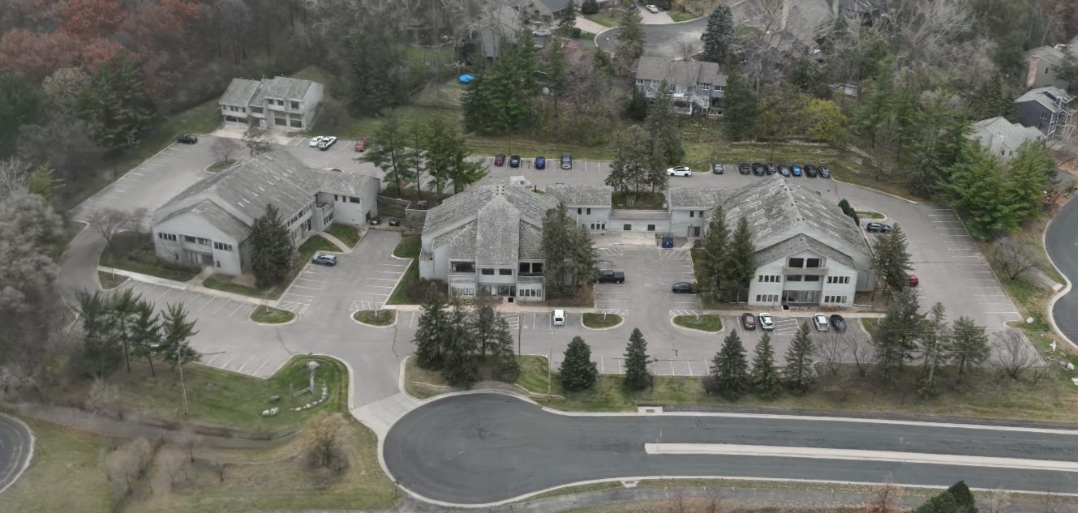

7805 Telegraph Rd
Telegraph Hill Office Park
Bloomington, MN 55438
Parcel ID: 18-116-21-11-0027
Legal Description: LOT 002 BLOCK 001 T TELEGRAPH HILL OFFICES IRREGULAR

7815 Telegraph Rd
Telegraph Hill Office Park
Bloomington, MN 55438
Parcel ID: 18-116-21-11-0028
Legal Description: LOT 003 BLOCK 001 T TELEGRAPH HILL OFFICES IRREGULAR

7825 Telegraph Rd
Telegraph Hill Office Park
Bloomington, MN 55438
Parcel ID: 18-116-21-11-0029
Legal Description: LOT 004 BLOCK 001 T TELEGRAPH HILL OFFICES IRREGULAR

7835 Telegraph Rd
Telegraph Hill Office Park
Bloomington, MN 55438
Parcel ID: 18-116-21-11-0033
Legal Description: LOT 002 BLOCK 001 T TELEGRAPH HILL OFFICES 2ND ADDN SE 123X134X67X185

7845 Telegraph Rd (Common Areas)
Telegraph Hill Office Park
Bloomington, MN 55438
Parcel ID: 18-116-21-11-0032
Legal Description: LOT 001 BLOCK 001 T TELEGRAPH HILL OFFICES 2ND ADDN SUBJECT TO STREET IRREGULAR



